

**Green University of Bangladesh**

**Department of Computer Science and Engineering (CSE)**

**Semester: (Spring, Year:2024), B.Sc. in CSE (Day)**

**Lab Report NO #02**

**Course Title: Database System Lab**

**Course Code: CSE 210 Section: 221 D1**

**Lab Experiment Name: Implementation of Integrity Constraints in MySQL.**

**Student Details**

| **Name** | | **ID** |
| --- | --- | --- |
| **1.** | Tanvir Ahmed | 221002461 |

**Lab Date : 11/3/2024**

**Submission Date : 18/3/2024**

**Course Teacher’s Name : Dr. Faiz Al Faisal**

| **Lab Report Status**  **Marks: ………………………………… Signature:.....................**  **Comments:.............................................. Date:..............................** |
| --- |

**1. TITLE OF THE LAB REPORT EXPERIMENT**

Implementation of integrity constraints in MySQL

**2. OBJECTIVES/AIM**

* To create a database
* To create tables in the database
* To declare the primary key
* To implement unique constraint
* To implement foreign key constraint
* To insert data into each table
* To describe tables
* Browse each table

**3. PROCEDURE**

1. At first, we created a database named lab3.
2. Then we create a table named employees with a primary key.
3. Again create a table named group1 with a primary key and a unique key.
4. Create the third table named group2 with a primary key, foreign key, and unique key.
5. Insert data on each table.
6. Show all information from each table.

**4. IMPLEMENTATION**

Source Code:

1. Creating a Database:

CREATE DATABASE lab3;

1. Creating a Table:

use lab3;

CREATE TABLE employees(employee_no int PRIMARY KEY, name varchar(20), age int);

1. To describe the table:

USE lab3;

DESC employees;

1. Create another table with unique key:

use lab3;

CREATE TABLE group1(employee_no int not null, phone_no int not null, designation varchar(20), PRIMARY KEY(phone_no), UNIQUE KEY(employee_no));

1. Creating a third table with a primary key a foreign key a unique key.

CREATE TABLE group2(employee_no int not null, phone_no int not null, designation varchar(20), PRIMARY KEY(phone_no), FOREIGN KEY(employee_no) REFERENCES employees(employee_no),UNIQUE KEY(designation));

1. Inserting data on the table ‘employees’:

use lab3;

INSERT INTO employees VALUES(1,"Sophia", 30);

INSERT INTO employees VALUES(2,"William", 48);

INSERT INTO employees VALUES(3,"Noah", 36);

INSERT INTO employees VALUES(4,"David", 39);

INSERT INTO employees VALUES(5,"Evelyn", 38);

1. Inserting data on the table ‘group1’:

use lab3;

INSERT INTO group1 VALUES(1, 01712345678, 'Marketing Manager');

INSERT INTO group1 VALUES(3, 01703647283, 'Accountant');

INSERT INTO group1 VALUES(5, 01738594738, 'Graphic Designer');

1. Inserting data on the table ‘gorup2’:

use lab3;

INSERT INTO group2 VALUES(2, 01787654321, 'Software Engineer');

INSERT INTO group2 VALUES(4, 01784568392, 'Data Analyst');

INSERT INTO group2 VALUES(5, 01738594738, 'Graphic Designer');

1. To see all the information in each table:

USElab3 ;

SELECT * FROM employees;

SELECT * FROM group1;

SELECT * FROM group2;

**5. TEST RESULT / OUTPUT**

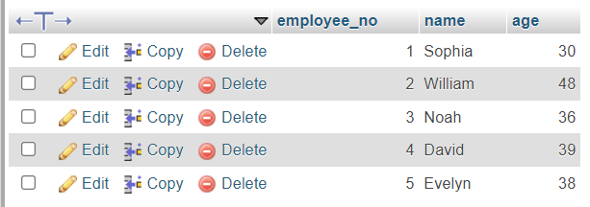

fig1. Browsing the table ‘employees’.

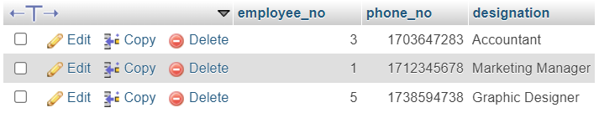

fig2. Browsing the table ‘gorup1’.

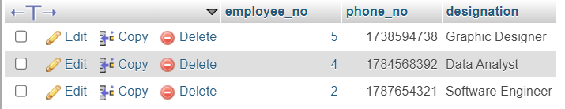

fig3. Browsing the table ‘group2’.

**6. ANALYSIS AND DISCUSSION**

* In this exercise, at first, the database called ‘lab3’ was successfully created.
* Then we created 3 tables named ‘employees’, ‘group1’, and ‘group2’ within the ‘lab3’ database by implementing the keys that I learned from the previous class.
* We insert some information into each table using INSERT INTO statements.
* We describe the table using the DESC command.
* To see all the information in each table we use SELECT * FROM tablename command.

**7. SUMMARY**

This lab exercise demonstrates practical applications of SQL commands especially to implement all keys that I learned from the previous class. We implement the exercise by creating a database, and table, inserting data into each table, and browsing each information.